Mutual Fund Analytics Capstone Project
Project Title:
Mutual Fund Analytics Platform
Advanced Data Analytics & Business Intelligence Capstone Project
Submitted by:
Seelam Venu Keerthana
Date: July 2026
Abstract
The Mutual Fund Analytics Platform is a comprehensive financial analytics project designed to transform raw mutual fund data into meaningful investment insights. The project integrates Python, SQLite, SQL, and Power BI to build an end-to-end analytics pipeline covering data ingestion, cleaning, exploratory analysis, financial performance evaluation, portfolio analytics, benchmark comparison, and advanced risk analysis.
The project analyzes historical Net Asset Value (NAV), investor transactions, fund performance, benchmark indices, portfolio holdings, and fund house information. Advanced financial metrics including CAGR, Sharpe Ratio, Sortino Ratio, Alpha, Beta, Maximum Drawdown, and Value at Risk (VaR) were computed to evaluate investment performance and risk. Interactive Power BI dashboards were developed to visualize industry trends, investor behavior, portfolio allocation, and benchmark performance.
The project demonstrates how data analytics and business intelligence can assist investors in making informed mutual fund investment decisions.
Introduction
Mutual funds have become one of the most preferred investment options due to their diversification and professional management. However, investors often struggle to compare schemes, evaluate historical performance, measure risk, and identify suitable investment opportunities.
This project addresses these challenges by building a complete Mutual Fund Analytics Platform capable of analyzing financial datasets and presenting actionable insights through interactive dashboards and advanced analytics techniques.
Problem Statement
The mutual fund industry generates a significant volume of financial data every day. Investors require efficient tools to analyze fund performance, compare schemes, evaluate risk, and monitor investment portfolios. Traditional spreadsheet-based analysis becomes difficult as data volume increases.
Therefore, an integrated analytics platform is required to automate data processing, calculate financial metrics, and provide meaningful visualizations for investment decision-making.

Objectives
- Analyze historical NAV data
- Study investor behavior
- Evaluate mutual fund performance
- Calculate financial risk metrics
- Develop interactive Power BI dashboards
- Build a recommendation engine
- Perform Value at Risk (VaR) analysis
- Generate actionable investment insights
Dataset Description
The project uses ten datasets containing mutual fund information.
Dataset | Description
Fund Master | Scheme information
NAV History | Historical NAV values
AUM by Fund House | Assets under Management
Monthly SIP Inflows | SIP investments
Category Inflows | Category-wise investments
Industry Folio Count | Investor folio statistics
Scheme Performance | Returns and ratios
Investor Transactions | Transaction history
Portfolio Holdings | Equity holdings
Benchmark Indices | Market benchmark data
Dataset Statistics
- NAV Records: 46,000
- Investor Transactions: 32,778
- Mutual Fund Schemes: 40
- Portfolio Holdings: 322
- Benchmark Records: 8,050
- Unique Investors: 5,000
Technology Stack
Technology | Purpose
Python | Data Analysis
Pandas | Data Processing
NumPy | Numerical Computation
Matplotlib | Visualization
SQLite | Database
SQL | Data Querying
Power BI | Dashboard Development
Git & GitHub | Version Control
Jupyter Notebook | Analysis Environment
ETL Pipeline
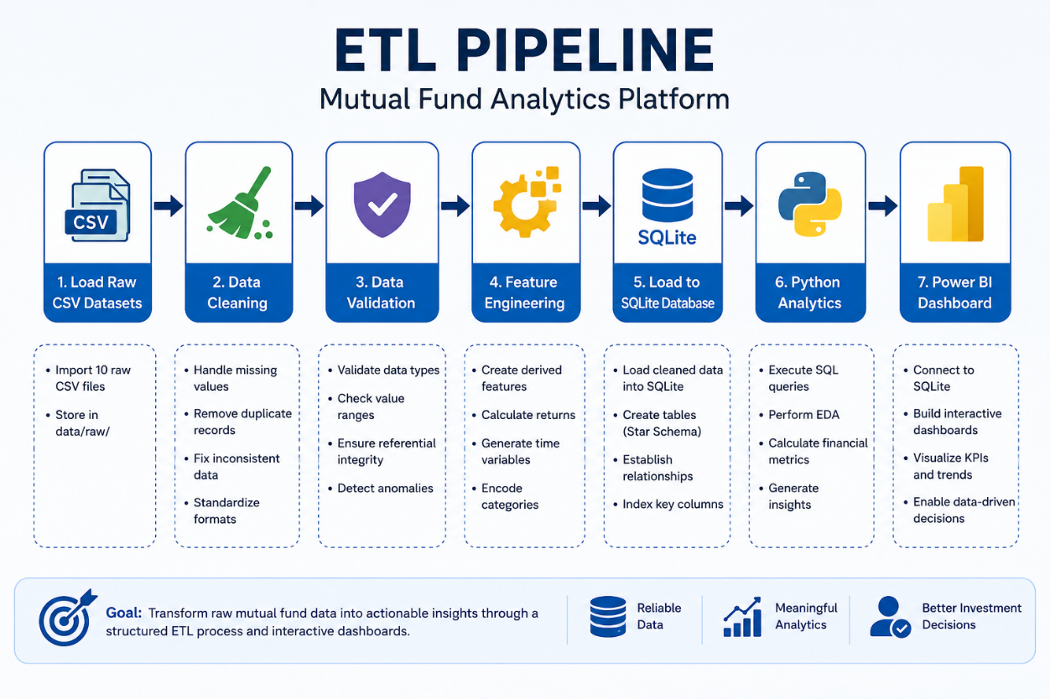

The ETL process consists of the following stages:
- Load raw CSV datasets
- Clean missing and duplicate records
- Validate data quality
- Transform variables
- Load cleaned data into SQLite
- Perform analytical queries
- Generate dashboards
Exploratory Data Analysis
EDA was performed to understand trends across funds, categories, and investors.
Key analyses include:
- NAV Trend
- Category-wise Returns
- Fund House Comparison
- Investor Demographics
- Portfolio Allocation
NAV Trend
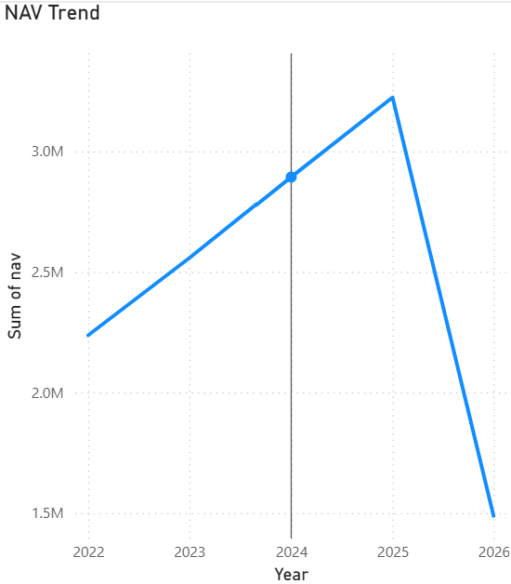

Performance Analytics
Several financial metrics were computed to evaluate mutual fund performance.
These include:
- CAGR
- Sharpe Ratio
- Sortino Ratio
- Alpha
- Beta
- Maximum Drawdown
- Standard Deviation
These metrics provide insights into both return potential and investment risk.
Power BI Dashboard
An interactive Power BI dashboard consisting of five pages was developed.
The dashboard includes:
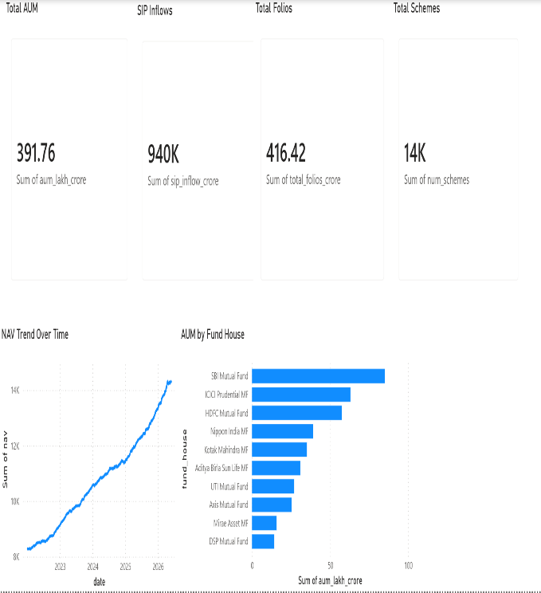
Industry Overview Fund Performance
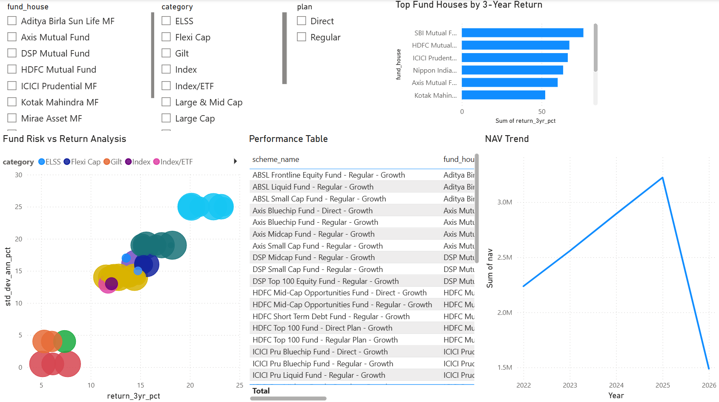

Investor Analytics Portfolio Holdings
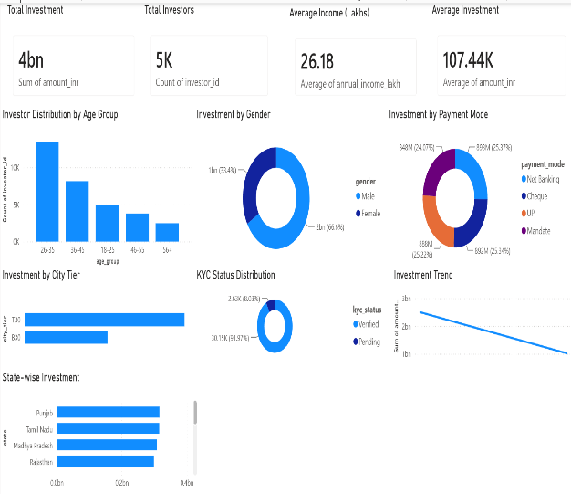
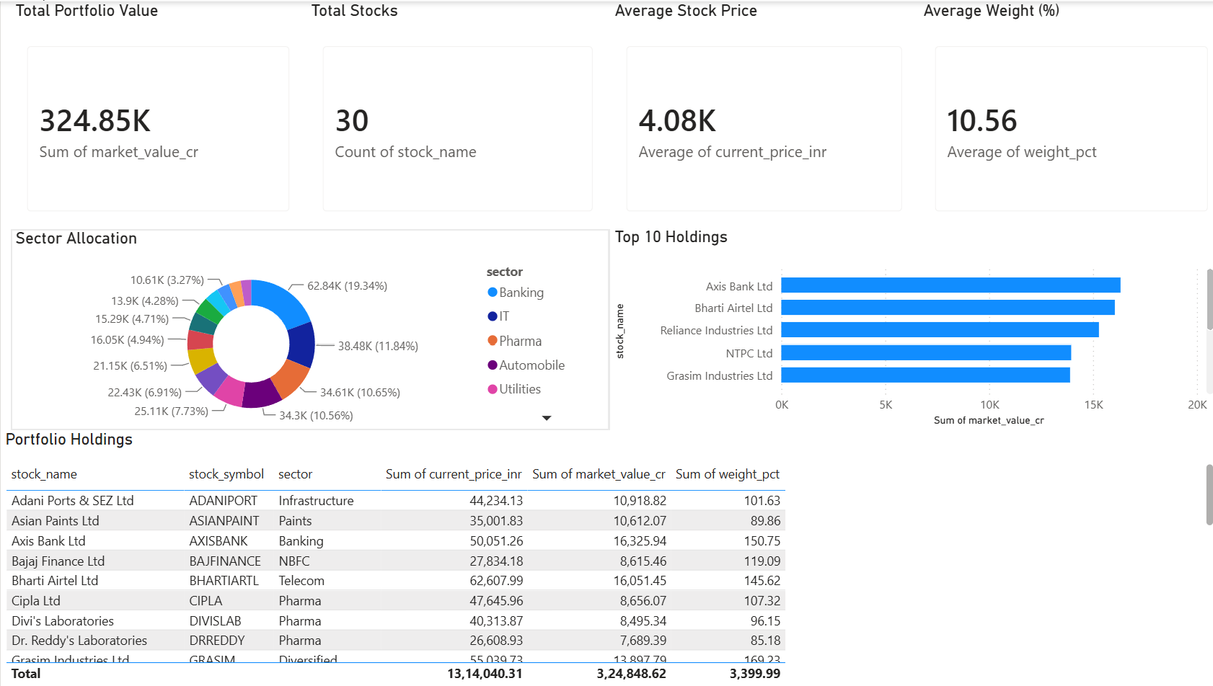
Benchmark Analysis
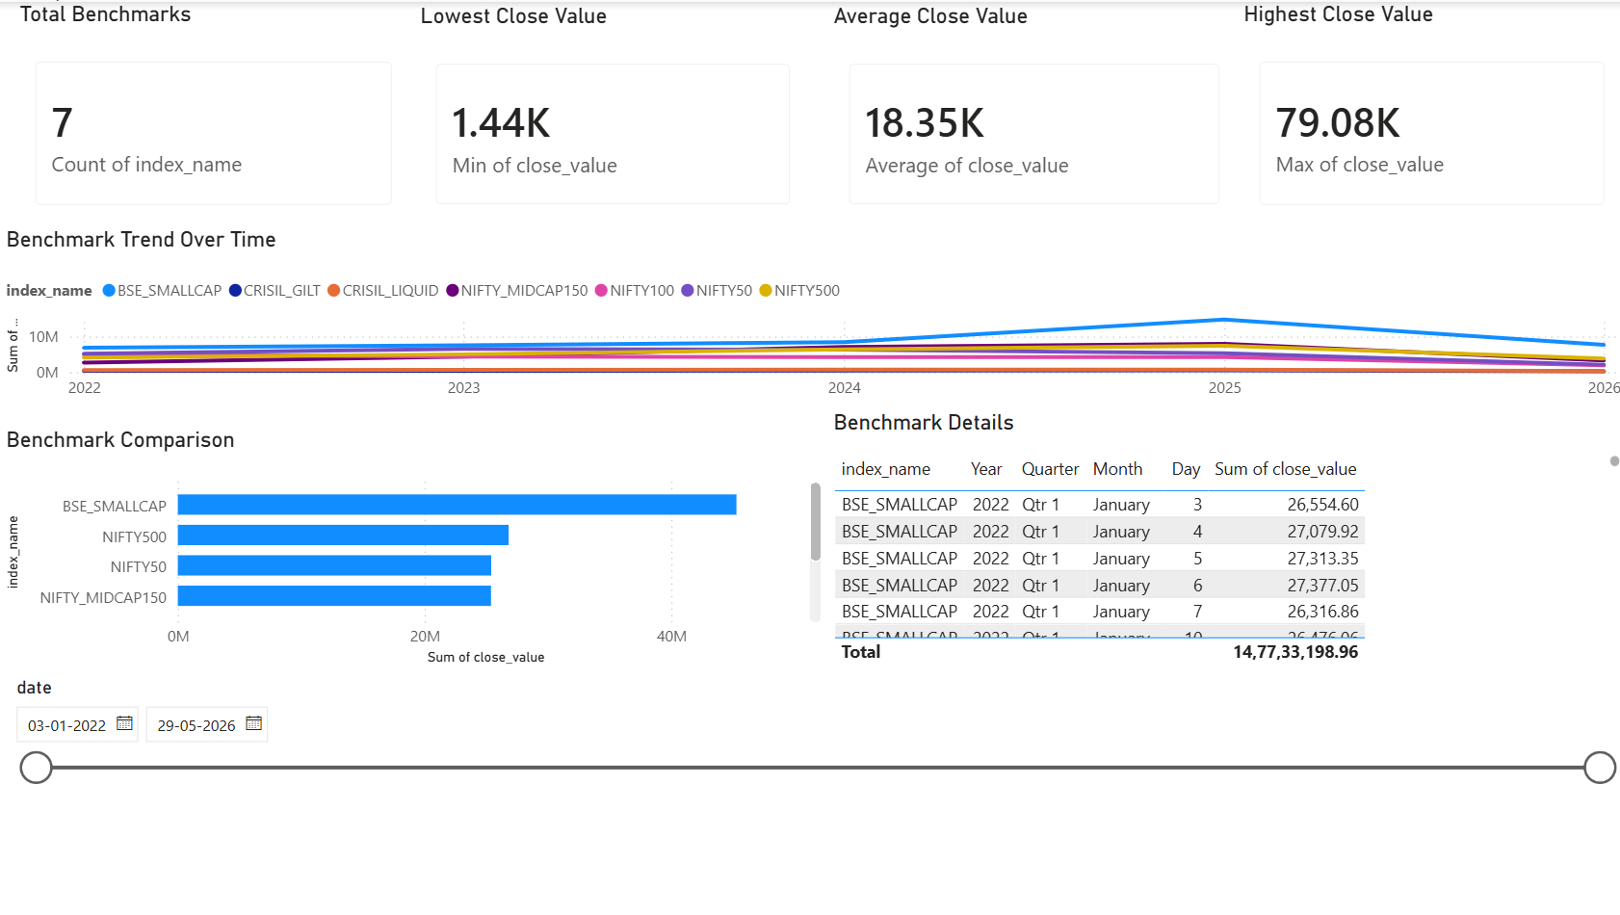
Advanced Analytics
Advanced analytical techniques implemented include:
Value at Risk (VaR)
Historical daily returns were used to estimate the 95% Value at Risk.
Result:
95% VaR = -1.63%
Monthly Cohort Analysis
Investor activity was grouped by month to analyze participation trends and retention.
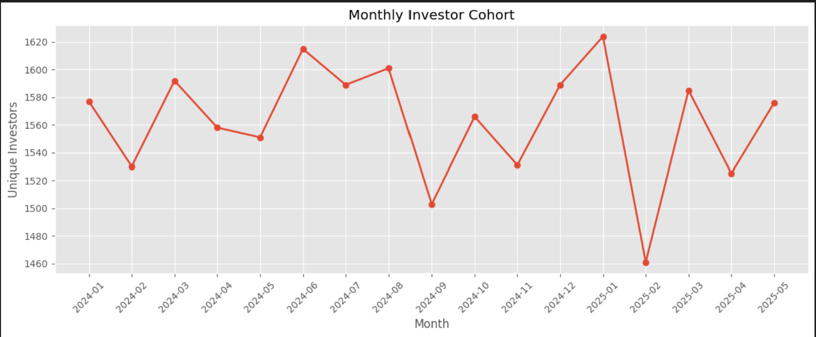
IMG: Monthly Investor Cohort
Recommendation Engine
A recommendation score was calculated using:
- 3-Year Return
- Sharpe Ratio
- Annual Volatility
The system ranks mutual funds based on risk-adjusted performance.
Key Findings
- Large Cap funds demonstrated stable long-term performance.
- Liquid funds exhibited the lowest investment risk.
- Investors aged 26–35 contributed the highest investment volume.
- Verified KYC investors accounted for the majority of transactions.
- Recommendation scores successfully identified top-performing funds.
- Interactive dashboards simplified financial analysis and decision-making.
Conclusion
This project successfully demonstrates how financial analytics, Python programming, SQL databases, and Power BI dashboards can be integrated into a complete business intelligence solution.
The platform transforms raw mutual fund data into actionable insights that support better investment decisions through quantitative analysis, visualization, and risk assessment.

Future Scope
Potential enhancements include:
- Live Mutual Fund API integration
- AI-based recommendation engine
- Streamlit web application
- Portfolio optimization using Modern Portfolio Theory
- Monte Carlo simulation for NAV forecasting
- Automated ETL scheduling
- Weekly email performance reports
References
[1] Association of Mutual Funds in India (AMFI). https://www.amfiindia.com/

[2] MFAPI – Mutual Fund NAV API. https://www.mfapi.in/

[3] Microsoft Power BI Documentation. https://learn.microsoft.com/power-bi/

[4] Python Software Foundation. Python Documentation. https://docs.python.org/3/

[5] Pandas Documentation. https://pandas.pydata.org/docs/

[6] NumPy Documentation. https://numpy.org/doc/

[7] Matplotlib Documentation. https://matplotlib.org/stable/

[8] SQLite Documentation. https://www.sqlite.org/docs.html

[9] Jupyter Notebook Documentation. https://jupyter-notebook.readthedocs.io/

[10] Git Documentation. https://git-scm.com/doc

